# Instructor’s Resource Manual

# *For*

# E-Commerce 2018:

# Business, Technology and Society

# Fourteenth Edition

## Kenneth C. Laudon, *New York University*

## Carol Geurcio Traver, *Azimuth Interactive*

Boston Columbus Indianapolis New York San Francisco Hoboken

Amsterdam Cape Town Dubai London Madrid Milan Munich Paris Montreal Toronto

Delhi Mexico City Sao Paolo Sydney Hong Kong Seoul Singapore Taipei Tokyo

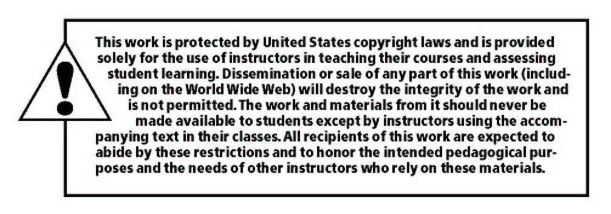

______________________________________________________________________________

Copyright © 2019, 2018, 2017 by Pearson Education, Inc. or its affiliates.  All Rights Reserved.  Printed in the United States of America. This publication is protected by copyright, and permission should be obtained from the publisher prior to any prohibited reproduction, storage in a retrieval system, or transmission in any form or by any means, electronic, mechanical, photocopying, recording, or otherwise. For information regarding permissions, request forms and the appropriate contacts within the Pearson Education Global Rights & Permissions Department, please visit [www.pearsoned.com/permissions/](http://www.pearsoned.com/permissions/).

Instructors of classes using *E-Commerce 2018 : Business, Technology and Society, 14th Edition, by Kenneth C. Laudon and Carol Guercio Traver* may reproduce material from the Instructor’s Resource Manual and Test Bank for classroom use.

10 9 8 7 6 5 4 3 2 1 ISBN-10: 0134867157

ISBN-13:  9780134867151

www.pearsonhighered.com